Final Project: Design Thinking

[Methods](https://static1.squarespace.com/static/57c6b79629687fde090a0fdd/t/58890239db29d6cc6c3338f7/1485374014340/METHODCARDS-v3-slim.pdf)

[Sprint (more methods)](https://static1.squarespace.com/static/57c6b79629687fde090a0fdd/t/58d3fa1e20099e1b0371a403/1490287182304/DESIGN+THINKING+PLAYBOOK.pdf)

What is design thinking?

Design thinking is a methodology used by designers to solve complex problems, and find desirable solutions for clients. A design mindset is not problem-focused, but solution focused and action oriented towards creating a preferred future. In this module, we will be exploring the first step: empathy.

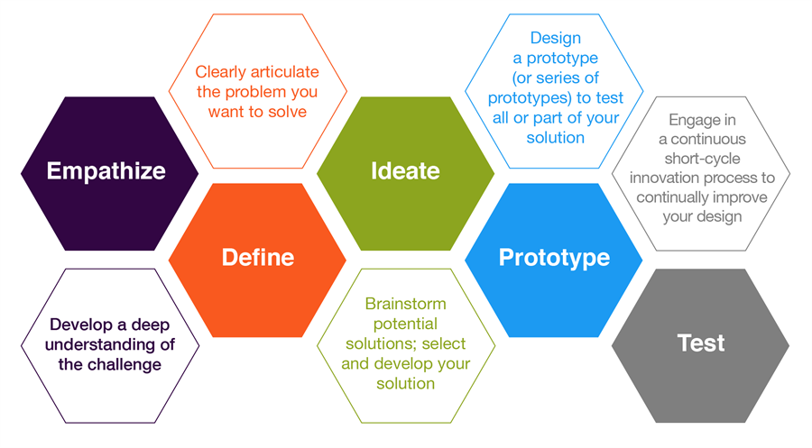

Step 1: Empathy

Empathy is the foundation of a human-centered design process; by deeply understanding people, we are better able to design for them.

Immerse: Experience what your user experiences.

Observe: View users and their behaviors in the context of their lives.

Engage: Interact with and interview users through both scheduled and short encounters.

Discover: Uncover people’s expressed and latent needs to best design solutions for them.

Understand: Through observation and interviews, we can build a picture of our users’ motivations based on what they say, do, think, and feel.

Activity: Observation:



What? What are the people doing (what are the concrete, observable facts)?

How? How are they doing that? (what emotions and techniques are present?)

Why? Why are the people doing that? In what way? (what inferences can we draw?)

Activity: Interview

1. Build rapport.
2. Seek stories.
3. Talk about feelings.

**Can you tell me about something you do outside of school?**

How do you feel about . . . ?

Can you tell me about how you started . . . ?

What is your best/worst/craziest/most memorable experience with . . .?

What’s something I would find surprising about . . . ?

How do you feel about . . .?

What’s a typical day like doing . . . ? An atypical day?

Why is . . . important to you? Why do you feel that way?

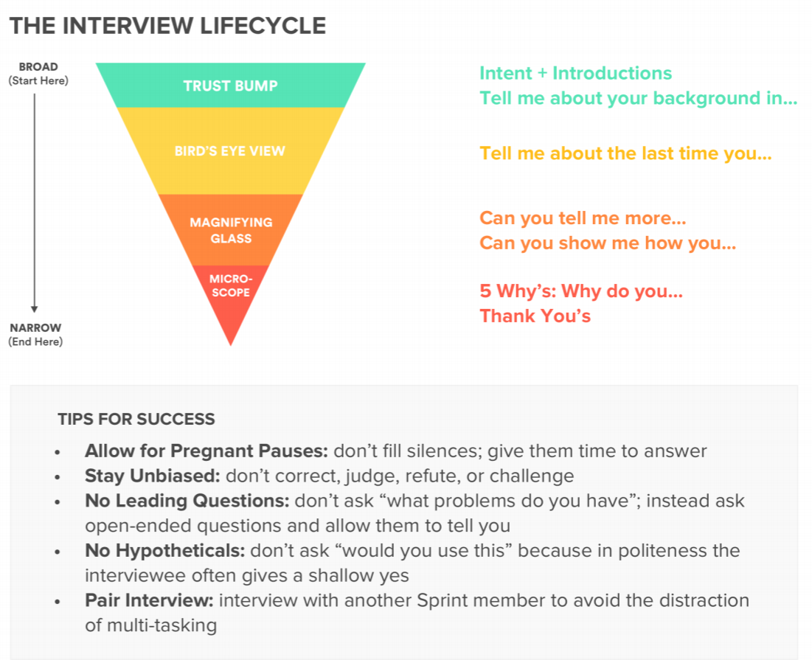

Notes/sketches/findings:

Analysis:

Observable needs: What are some problems your user is facing?

Latent needs: What do your observations say about this person outside of this context? How do they feel? What motivates them?